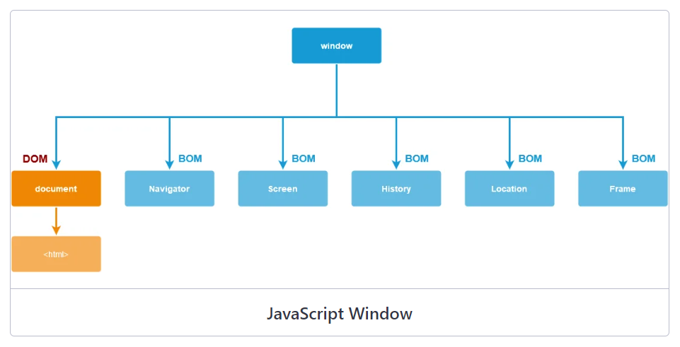

BOM

    Browser Object Model

    includes properties/methods for js to interacr with the web browser

    it provide syou with window object,

    width, height of the window

    screen objcets

    window objects -

    all the browsers

    - browser windows

    all global js objects, functions variables they all become members of the window objects

    global variables-  properties

    functoions - methods of window object

    document.get -- the property of window object

    window.document.getElementById();

    document.getElelmentById()

    innerHeight

    innerWidth -- size pf the browser window

    return sie in pixels

Window object represents the browser window

It is the topmost object in the browser window

* Fram/window in which the webpage is contained

window.alert()

everything which is visible or non visible to a user on a webpage are all part of the window

window.console.log

window.alert

window.document.get

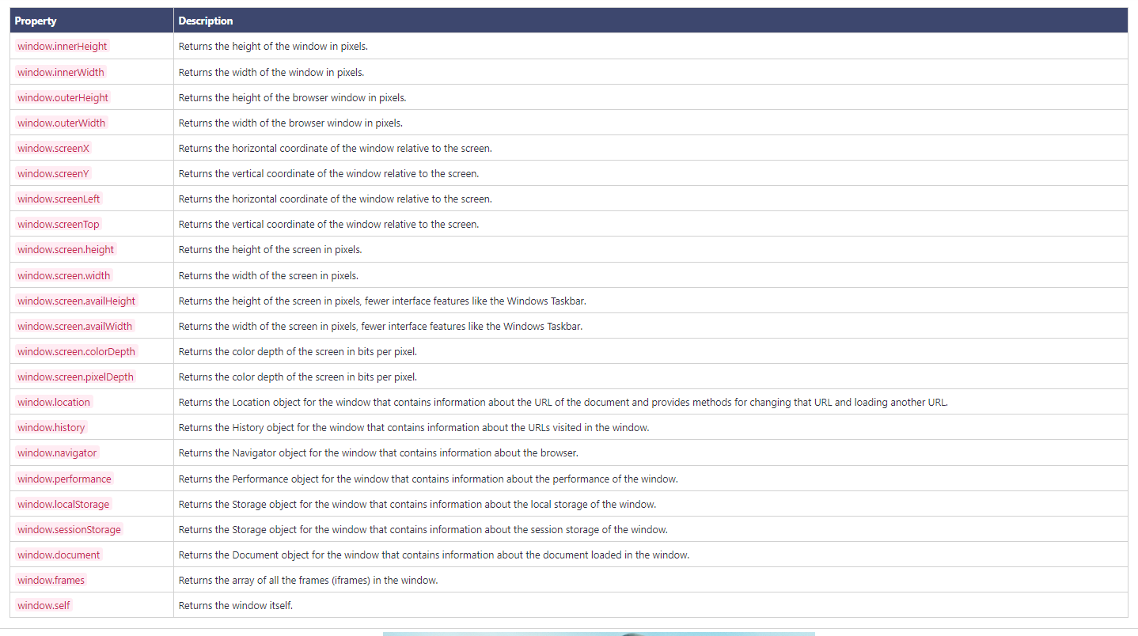

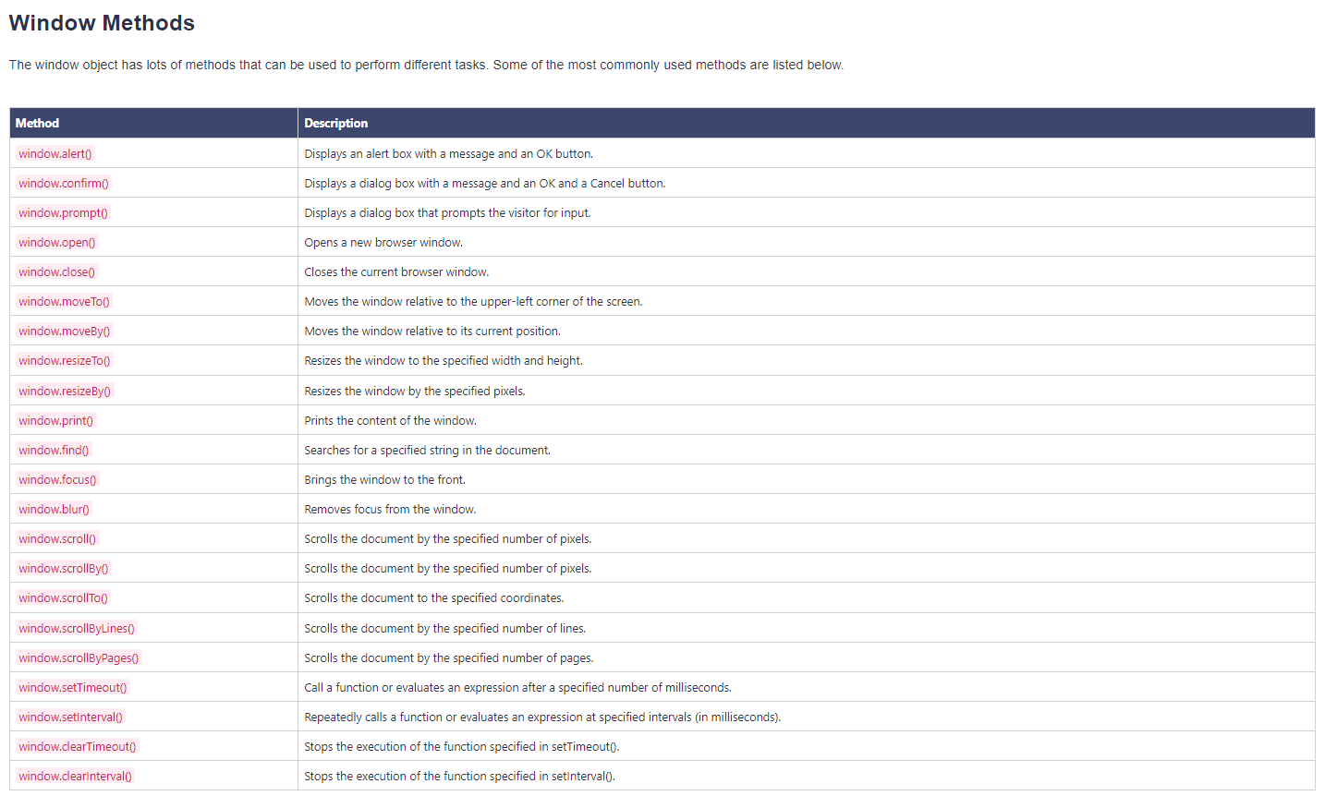

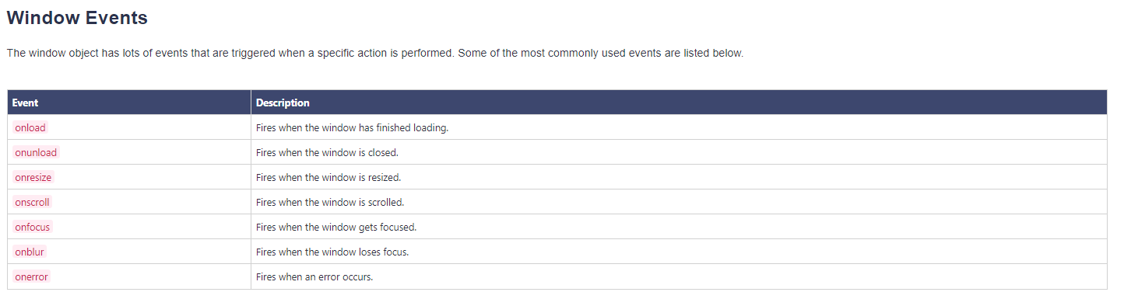

Q1- what is a jS Window?

Global object in the browser

It is the outermost object in the browser.

Parent of all the other objects

Everything in the browser is a child of a window object

Navigator Object –

Info abput the web browser and OS

Window.navigator

Navigator

* Read-only property
* Info that can be retrieved from it
* User is online
* Platform
* Browser
* Browser version
* Cookies
* Browser lang

appName – name of the browser

appCodeName – code name of the browser

userAgent – it includes all the information regarding the browser and OS

language- lang f the webpage

Location –

If you wan to get all info about the current page URL – location object

Current URL,hostname,pathname,protocol,port,related info

Href

Protocol

Host

Hostname

Port

Assign()

Reload()

Replace()

History object –

Stores the information about thw history of the window

Browserd keep data abput the history of the current window

All the pages that you visit they get stored in a list

Alert()

Confirm()

Prompt()

History objwct –

History object

Window.history

Length

Go() – used to load wthe particular page-forward /backward from history urls

Back()

Forward()

The browser history object contains the history of all the webpages/url the user has visited

Cookie-

What are cookies?

Maintain the session information

How this works?

Cookies are just plain text

5 variables

-

Expires

Domain

Path

Secure

Name=value

Were originally developed for CGI programming –

The data is contained in the cookie gets automatically transfereef between server and browser

Document.cookie=”key1:value1;key2:value2;expires=date”;

Question –

Read the cookie

String methods

String

;

Split()

-Session managememnt

Websites recognise the users and recall their individual login information and preferences

-Personalization

-tracking

Timing Events –

setInterval(function,ms)- repeats the execution of the function contiously

SetTimeout(func,ms) –

After waiting a specified no of ms

Window objects